**How to create your own Python Package?**

**If you face any issues, please refer to package docs/note file.**

1. Make a repository on GitHub.
2. Add a license and. gitignore file to that repository.

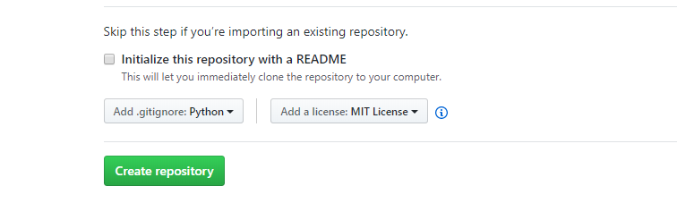

1. Now clone this repository into your local machine.
2. Now, make the package structure by adding these directories and files,

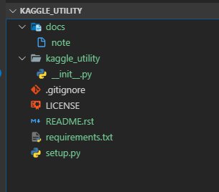

1. Now, make a virtual env using **git_bash** console as **source** command does not work on **cmd**,

* pip install virtualenv
* virtualenv venv
* source venv/Scripts/activate

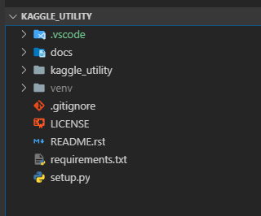

1. Specify your dependencies in **requiremens.txt**,

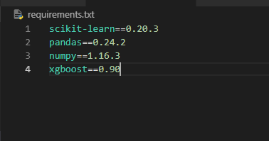

and Now install your dependencies in this env using,

* pip install -r requirements.txt

Make sure to deactivate your env after installing libraries by using,

* deactivate venv

1. Make a **setup.py** file and mention the metadata as,

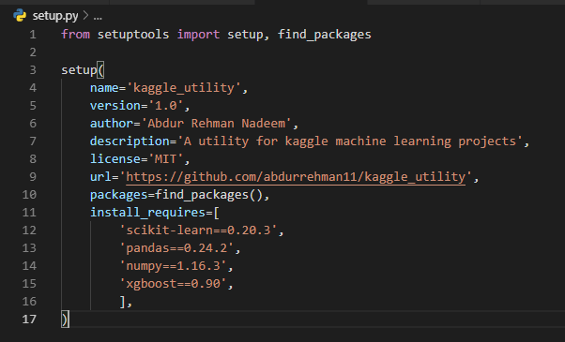

1. Now register yourself on <https://pypi.org/>
2. Now build your project for deployment as,

python -m pip install --user --upgrade setuptools wheel

python setup.py sdist bdist_wheel

After successful running above commands, you will have

dist/

example_pkg_your_username-0.0.1-py3-none-any.whl

example_pkg_your_username-0.0.1.tar.gz

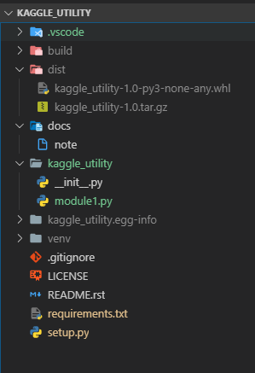

1. Now, upload your project to pypi using these steps,

python -m pip install --user --upgrade twine

python -m twine upload dist/*

After entering your correct credentials, your package will be uploaded to <https://pypi.org/manage/projects/>

and will be available globally.

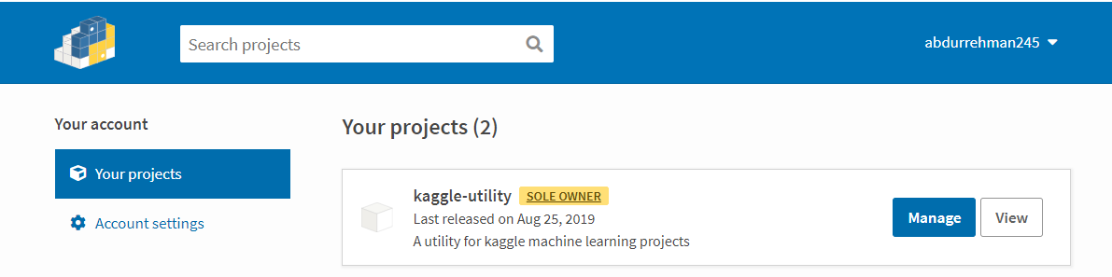

1. To install your package,

